 | TAFL  (ACSE-0404)  UNIT-I  Assignment-1.1 |  | SESSION: 2021-22
 |  |  | CLASS/SEM: B.Tech AI -IVth (EVEN)
Assignment Given Date: 11 /3/2022  Assignment Submission Date: 22/3/2022 |  | Maximum Points: 10
 |  | Weightage in University Exam:
Faculty Name: Sonia Arora |  | Faculty Mail Id: soniaarora@niet.co.in

- Design a DFA in which abba is a substring over Σ={a,b}.
- Explain how complementing a language is different from complementing a NFA. Compare the NFA and epsilon-NFA.Differentiate Mealy and Moore Machine.
- Design a NFA over{0,1} for a language such that all stringstartswith‘0’and ends with‘1’. Convert this NFA to DFA.
- Construct a mealy m/c that takes a binary number as input and produces 1’scomplementof that number as output. Assume the string is read from LSB to MSB and end carry is discarded.
- Give the DFA accepting the following languages over the alphabet{0,1}:
(i) Which accepts set of all strings such that it contains substring‘01’.
(ii)Which accepts set of all strings such that the binary number is divided by3.
- Design a DFA for the Language, L={a^{2n}b^{m} /n,m>=0} .Differentiate Kleene and Positive Closure.
- Design a NFA over {a,b} such that third symbol from right side is ‘baa’.
- Convert NFA to DFA by taking suitable example. Prove how simulation of NFA and DFA can be done.
- Minimize the automata given below 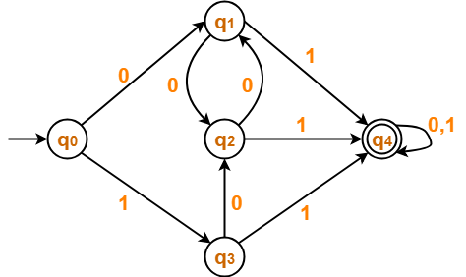
- Convert the following NFA to DFA

States/input | a | b
->q1 | q1, q2 | q1
q2 | q3 | q2
* q3 | q4 | q4
* q4 | -- | q3

